FishMIP v3 plug-in for EwE and EcoOcean
- a brief users’ guide -



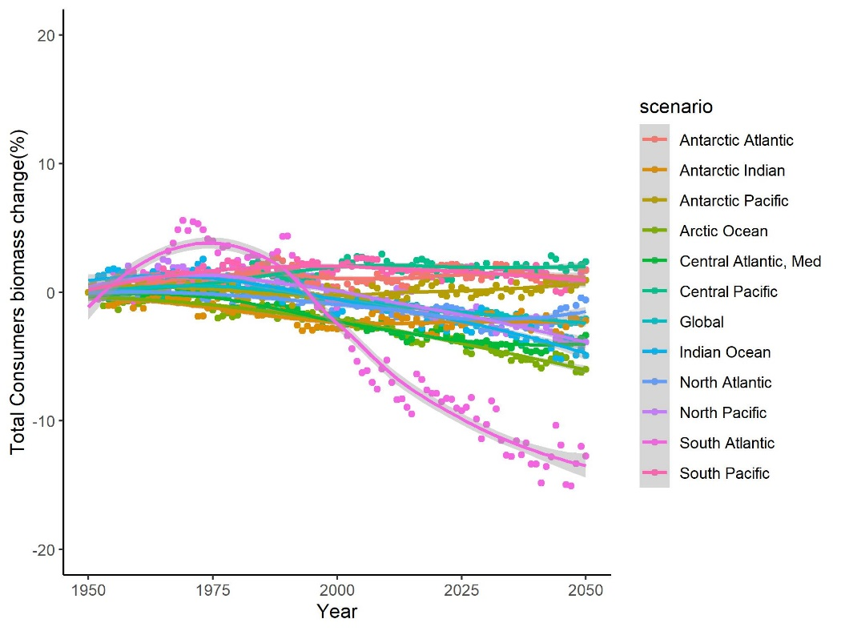
Version 1, 6 May 2021

Introduction
Running a large number of FishMIP-like experiments through the EwE software can be an error-prone process; it is easy to overlook a setting when configuring fishing and environmental impacts to represent correctly the various experiments. The FishMIP v3 plug-in aims to simplify this process by acting as an intermediary between the run protocol and the EwE software. Once a user has configured how the climate and fishing assumptions in the protocol translate to the EwE / EcoOcean fisheries time series and Ecospace map layers, and how the model output translates to the protocol needs, the plug-in can then be used to select and run experiments with a few clicks of a mouse.
Although originally written to execute EcoOcean simulations for FishMIP and TRIATLAS, the plug-in can be used to any run protocol through Ecospace.
Concept and coding: Jeroen Steenbeek, Ecopath International Initiative, Spain
 |  |  | 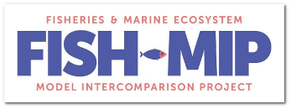

System requirements
Your computer needs the following to run the software:
- Microsoft Windows 7 or newer
- .NET framework version 4.7 or newer
- Ecopath with Ecosim (EwE) or EcoOcean desktop software, Pro edition
- FishMIP v3 plug-in
- Spatial temporal data framework plug-in
- Ecospace spin-up plug-in
- Ecological indicators plug-in
- Access 2010 or newer database drivers to load and save EwE models
For assistance, contact EwE user support at eweusers@gmail.com

Setting up

The protocol
Run protocols, such as stipulated by FishMIP, outlines how to incorporate ecological and socio-economic scenarios into marine ecosystem models. Whereas ecosystem modellers decide on the implementation of socio-economic scenarios, Global Climate Models provide the spatial-temporal trends of various variables for the climate scenarios. Run protocols further require standardized outputs in order to make the output of multiple models inter-comparable.
The FishMIP plug-in requires loading of a protocol file that outlines the experiments conducted for a given set of model runs and which model output contributes to the simulation runs (Figure 1).
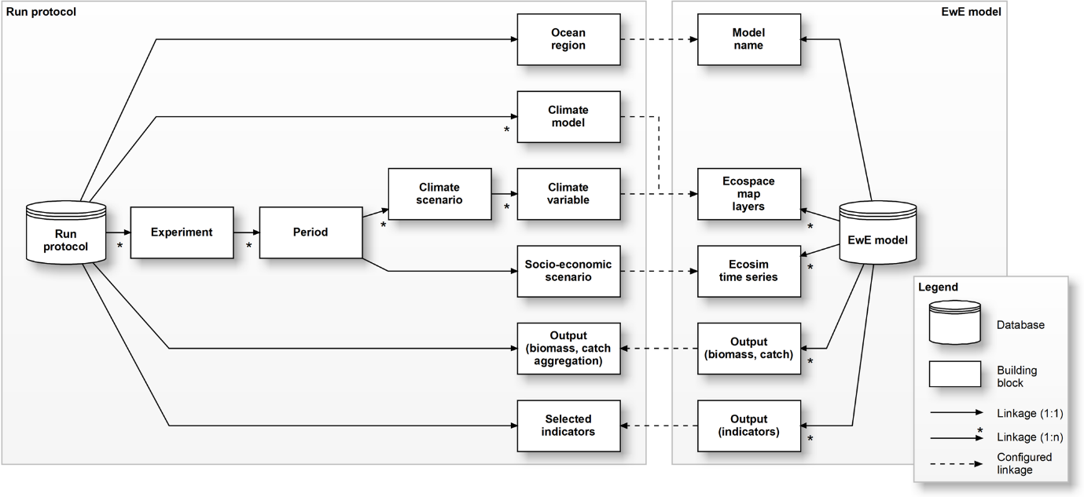
Figure 1 – The structure of a ‘protocol’ as used in the FishMIP plug-in, and how it connects to EwE. A run protocol has multiple experiments. Each experiment runs over one or more periods, during which specific climatological and socio-economic scenarios apply. For a given Ocean Region, the plug-in requires configuring (i) how socio-economic scenarios translate to Ecosim fishing effort time series, (2) how climate variables enter a running Ecospace model, and how EwE output needs summarizing to satisfy the aims of the project for which a run protocol was defined.

Incorporating climate scenarios
Climate scenarios are provided in the form of time series of maps, obtained from hydrodynamic or earth system models, and are brought into the Spatial Temporal Data Framework (STDF), a GIS-based data exchange for Ecospace (Steenbeek et al., 2013).
There are a few important things to note to make sure the Protocol and STDF can be interlinked:
The STDF accesses external spatial temporal data through the configuration file currently loaded in the EwE software. When running protocol experiments, all climatological data for a given protocol must be provided in the same configuration file.
The configuration file defines datasets, where each dataset holds a time series of maps dedicated to one specific Ecospace map layer, under one specific set of climatological assumptions. For instance, a configuration file may hold several datasets for surface temperature, where each dataset is dedicated to a specific model and run period (e.g., gfdl historical, gfl rcp26, gfdl rcp85, etc)
The FishMIP plug-in locates these datasets through a strict naming convention for datasets names:
dataset name = <climate model>_<climate scenario>_<climate variable>
where the names for the climate model, climate scenario and climate variable are defined in the protocol file. It is thus very important that names in the protocol file match names in the configuration file that the STFD uses.
For instance, if a protocol defines climate models with the names “gfdl”, “cesm” and “ipsl”, with climate scenarios “pi”, “hist”, and “ssp370”, and lists several variables among which “lphy”, “temp-150m” and “O2-bottom”, then the STDF could try to find datasets that with names such as:
- gfdl_hist_lphy
- cesm_ssp370_temp-150m
- ipsl_pi_O2-bottom
There are no limits to the climate models, climate scenarios or climate variables, as long as the names between the FishMIP plug-in protocol and the STDF configuration file match.
Please refer to the STDF manual or contact your favourite software developer how to populate configuration files.

Incorporate fishing
Fishing in EwE is driven by Ecosim effort time series that are distributed according to the gravity model in Ecospace. The FishMIP plug-in also uses this same system to resolve fishing scenarios in the protocol.
In Ecosim, a time series dataset contains any number of time series. Users import Time series datasets from CSV files. You will need to make sure that your Ecosim time series datasets contain the effort scenarios that you wish to run for the various experiments in the protocol.

Using the plug-in
The plug-in resides in the EwE navigation tree, and requires that an Ecospace scenario is loaded (Figure 2). Presuming that your model is ready to run, i.e. all time series datasets that match the socio-economic scenarios in a protocol have been imported, and the STDF configuration file that represents the climatological scenarios is loaded, then you’re ready to load a protocol, configure how it connects to the model, and start running.
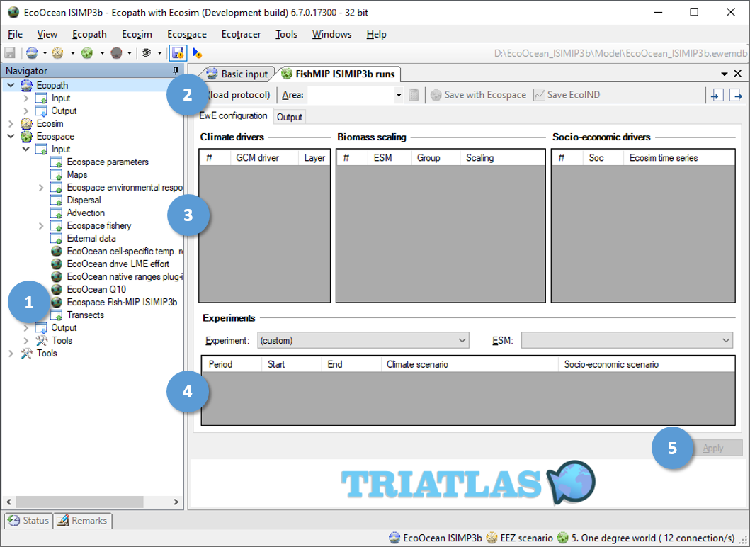
Figure 2 - The FishMIP plug-in, with its location in the navigation tree (1) and its main configuration options (2). The configuration section (3) allows users to configure how the drivers of climate and socio-economic scenarios map to the EwE software. Users select experiments in the experiments section (4). Any configuration change must be applied (5) to EwE before it is active.

Loading a protocol
A protocol is loaded by clicking the “Load protocol” button (See 2 in Figure 2). Browse to the protocol file, click open, to see the FishMIP interface reflect the protocol data. The name of the protocol is loaded from the contents of the XML file, and this name is shown in the “Load protocol” button (Figure 3).
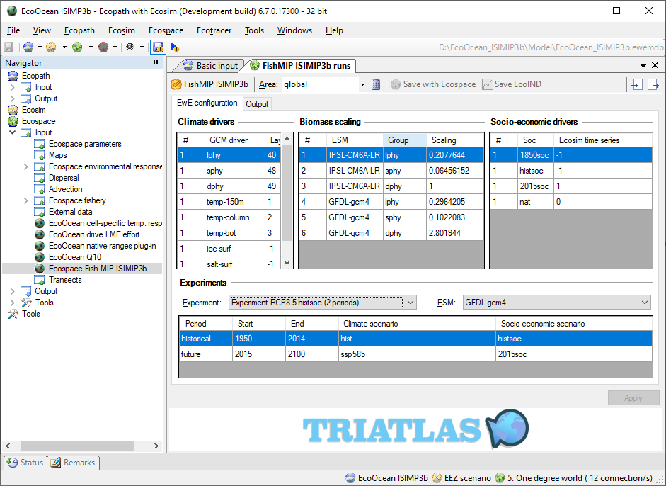
Figure 3 - The plug-in with a protocol loaded
If you previously configured how the protocol connects to EwE, then this previous work will load too. Internally, the FishMIP plug-in stores protocol configurations by the name of the protocol (the same name that is shown in the “Load protocol” button, as loaded from the XML file). This allows you to save configurations for any number of protocols within one model database, which can be quite handy if you wish to use the same model to run experiments for different protocols.

Configuring how the protocol connects to EwE
The configuration interface has two tabs: “EwE configuration” and “Output”. The first tab defines how the information in the protocol relates to Ecopath inputs; the second tab defines how EwE output is summarized for the protocol.

EwE configuration

Climate drivers
This section wants you to enter which Ecospace maps will be affected by the climate variables mentioned in the protocol. Climate variables are listed in the same order as the protocol, first variables that represent biomasses (phytoplankton, zooplankton, etc.), then variables that represent environmental conditions (temperature, dissolved oxygen, salinity, etc.). At the time of writing, the FishMIP plug-in does not yet support variables beyond these two types; perhaps one day we may wish to vary habitat maps, MPAs, etc. That would be easy to add if needed.
Connecting the climate variables to the model now means the following:
In the data grid, labelled “Climate drivers”, in the column “Layer”, enter the sequential number of the EwE biomass group OR the EwE environmental driver layer that you want to receive climatological maps. If your model cannot process a given climate variable, then leave the default at -1, which tells the FishMIP plug-in to ignore that variable (Figure 4).

Biomass scaling
This section obliges you to enter how external data (e.g., time series of maps) scales to your Ecopath baseline to drive the spatial distribution of biomasses of specific groups in Ecospace. This scaling needs to match your Ecopath baseline to make sure that external data integrates seamlessly.
The FishMIP plug-in interface has a convenient “Calculate” option in its main toolbar, but a more on this in the section “Experiments”, below.
For any given functional group, he FishMIP plug-in calculates the STDF biomass forcing scaling factor as follows:
 | $s=b/{\overline{M}}$, where $\overline{M}= \frac{1}{n}\left(\sum_{1}^{n}{\overline{m}}\right)$ | (Eq. 1)
where scaling factor s for that group is calculated by dividing the estimated Ecopath group biomass b by the mean external driver map value M, which in turn is the mean value of all external driver maps m that are available for the n Ecospace time steps that fall within Ecopath base year.

Socio-economic drivers
In this section, you enter how socio-economic scenarios are implemented by the various Ecosim time series that you have painstakingly prepared (Figure 5).
Now, there is a little catch here. The FishMIP plug-in presumes that every protocol may run for one or more periods, but that the periods largely represent a shared historical baseline with only one set of future socio-economic scenarios. In other words, between the various socio-economic scenarios stated in the protocol file, you need to work out how to best represent this combination in a single Ecosim time series, as the FishMIP plug-in is not (yet) clever enough to slice-and-stitch time series from different socio-economic scenarios for the different protocol run periods.
In order to be able to work around tis deficiency, the “Ecosim time series” column accepts three types of values:
- A value of “-1” indicates that there a given socio economic value is not considered for selecting a time series;
- A value of “0” indicates that a given scenario indicates an absence of fishing. The FishMIP plug-in will clear all efforts in this case;
- A positive value will use the corresponding Ecosim time series, which is presumed to provide effort trends for the entire model run.
As a recommendation, use “-1” for any historical time series, “0” for absence of fishing, and positive values (representing full model run time series that also incorporate historical effort) for any forecasting socio-economic scenario.

Experiments
Here comes the fun bit. Under “Experiment”, select the, well, experiment that you wish to run, and under “ESL”, select the climate model to drive the experiment. Click “Apply” to configure Ecospace, save if you wish, to configure Ecosim and Ecospace correctly to run an experiment.
Now about that “Calculate biomass scaling option”… This calculation happens on a selected experiment for the start year of your simulations. It should happen for your Ecopath base year, but this is unfortunately now how Ecosim time series work. So, the “calculate biomass scaling” option will look at the selected experiment, look up the protocol period that contains the simulation start year, find the corresponding external data sets, and will calculate the average for that start year as explained in equation 1.

Output configuration
The output tab has two panels (Figure 4).
On the left, indicate to which proportion each group contributes to each of the aggregated indicators (that were defined in the protocol). For legibility, this grid obscures zeroes. There are convenient options to either load EcoOcean defaults, or to have the plug-in trying to decipher which groups belong in which category by exploring the taxonomic composition of each group.
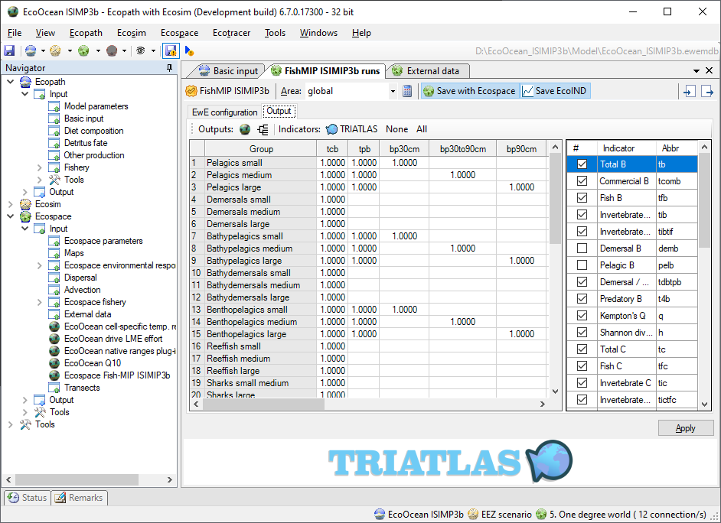
Figure 4 - Configuring the output for a protocol
On the right, one can select which ecological indicators are to be saved with model results. Ecological indicators save once per year and slow down the model runs significantly.

Running experiments
To run an experiment, do the following:
- Make sure a protocol is loaded and configured, and that biomass scalars are properly set;
- Make sure an area is selected (or typed) to ensure proper output formatting;
- Make sure that the protocol configuration is applied to EwE (click Apply), and validate that Ecosim runs as expected and that Ecospace has the correct external drivers loaded (in Navigator > Ecospace > Input > External data)
- Make sure that the “Save with Ecospace” and “Save EcoIND” are properly set;
- Make sure that the Ecospace spin-up plug-in is properly set
- Run Ecospace. Data will be saved to the output location indicated in “Menu > Tools > Options > File Management”

Reflections
When running repeated simulations, is it worth to go through the lengths of setting up a complicated protocol file, and does this extra effort offset the risk of making errors when manually configuring the EwE and EcoOcean user interfaces?
It depends on the projects, naturally. FishMIP protocols evolve, but retain a core that can be built upon by updating altering protocol files. Also, once a model is calibrated and a protocol file has been built, it is reasonably straightforward to adopt protocol files to new needs. Efforts to prepare a protocol file in line with external data for the STDF is a lot of work, but these efforts pay off when a model gets reused for other efforts.
Last, developing the protocol file helps ironing out errors prior to running the model.

Further work
Several improvements may be needed:
- Incorporate other Ecospace drivers such as MPA maps & temporal MPA dynamics, habitat maps;
- Allow “time slicing” effort time series and STDF driver sets that the cross time boundaries of the different periods;
- Extend the protocol to automate model runs;
- Extend the protocol to explore uncertainty;
- Bundle experiment runs under unique folders.

Acknowledgements
The application is part of the TRIATLAS project: South and Tropical Atlantic Climate-Based Marine Ecosystem Prediction for Sustainable Management (https://triatlas.w.uib.no). This project has received funding from the European Union’s Horizon 2020 research and innovation program under grant agreement number 817578.

References
Christensen V, Coll M, Steenbeek J, Buszowski J, Chagaris D, Walters, CJ (2014). Representing Variable Habitat Quality in a Spatial Food Web Model. Ecosystems 17: 1397–1412. https://doi.org/10.1007/s10021-014-9803-3
Christensen V, Walters CJ (2004) Ecopath with Ecosim: capabilities and limitations. Ecological Modelling 172: 109–139. https://doi.org/10.1016/j.ecolmodel.2003.09.003
Jones MV, West RJ (2005) Spatial and temporal variability of seagrass fishes in intermittently closed and open coastal lakes in southeastern Australia. Estuarine, Coastal and Shelf Science 64: 277–288. https://doi.org/10.1016/j.ecss.2005.02.021
Langseth BJ, Rogers M, Zhang H (2012) Modelling species invasions in Ecopath with Ecosim: An evaluation using Laurentian Great Lakes models. Ecological Modelling 247: 251–261. https://doi.org/10.1016/j.ecolmodel.2012.08.015
Sadchatheeswaran S, Moloney CL, Branch GM, Robinson TB (2019) Blender interstitial volume: A novel virtual measurement of structural complexity applicable to marine benthic habitats. MethodsX 6: 1728-1740. https://doi.org/10.1016/j.mex/2019.07.014.
Sadchatheeswaran S, Branch GM, Shannon LJ, Coll M, Steenbeek J (Submitted) A novel approach to explicitly model the spatiotemporal impacts of structural complexity created by alien ecosystem engineers in a marine benthic environment. Ecological Modelling
Steenbeek J, Buszowski J, Christensen V, Akoglu E, Aydin K, Ellis N, Felinto D, Guitton J, Lucey S, Kearney K, Mackinson S, Pan M, Platts M, Walters C (2016). Ecopath with Ecosim as a model-building toolbox: Source code capabilities, extensions, and variations. Ecological Modelling 319: 178–189. https://doi.org/10.1016/j.ecolmodel.2015.06.031
Steenbeek, J (2021). Ecospace spatial-temporal data framework a brief users’ guide (Barcelona, Spain: Ecopath International Initiative). https://doi.org/10.6084/m9.figshare.13551551.v1
Walters C, Pauly D, Christensen V (1999) Ecospace: Prediction of mesoscale spatial patterns in trophic relationships of exploited ecosystems, with emphasis on the impacts of marine protected areas. Ecosystems 2: 539–554. https://doi.org/10.1007/s100219900101

Appendix 1 – Example protocol file
<?xml version="1.0" encoding="utf-8" ?>
<run-protocol name="FishMIP ISIMIP3b">
<gcms>
<gcm name="ipsl" description="IPSL-CM6A-LR"/>
<gcm name="gfdl" description="GFDL-gcm4"/>
</gcms>
<variables>
<variable name="lphy" type="biomass"/>
<variable name="sphy" type="biomass"/>
<variable name="dphy" type="biomass"/>
<variable name="temp-150m" type="driver"/>
<variable name="temp-column" type="driver"/>
<variable name="temp-bot" type="driver"/>
<variable name="ice-surf" type="driver"/>
<variable name="salt-surf" type="driver"/>
<variable name="o2-bot" type="driver"/>
</variables>
<ocean-regions>
<ocean-region name="global" description="Global"/>
<ocean-region name="north-sea" description="North Sea"/>
<ocean-region name="baltic-sea" description="Baltic Sea"/>
<ocean-region name="nw-med-sea" description="North-west Meditteranean"/>
<ocean-region name="adriatic-sea" description="Adriatic Sea"/>run-protocol
<ocean-region name="med-glob" description="Mediterranean Sea"/>
<ocean-region name="se-australia" description="South-east Australia"/>
<ocean-region name="east-bass-strait" description="Eastern Bass Strait"/>
<ocean-region name="cook-strait" description="Cook Strait"/>
<ocean-region name="humboldt-n" description="Northern Humboldt current"/>
<ocean-region name="hawaii" description="Hawaii"/>
<ocean-region name="ne-brasil" description="North-east Brasil"/>
<ocean-region name="benguela" description="Benguela Current"/>
</ocean-regions>
<periods>
<period name="historical" start-year="1950" end-year="2014"/>
<period name="future" start-year="2015" end-year="2100"/>
</periods>
<climate-scenarios>
<climate-scenario name="pi" description="Pre-industrial climate as simulated by the GCMs"/>
<climate-scenario name="hist" description="Historical climate as simulated by the GCMs"/>
<climate-scenario name="ssp126" description="SSP1-RCP2.6 climate as simulated by the GCMs"/>
<climate-scenario name="ssp370" description="SSP3-RCP7 climate as simulated by the GCMs"/>
<climate-scenario name="ssp585" description="SSP5-RCP8.5 climate as simulated by the GCMs"/>
</climate-scenarios>
<socio-econ-scenarios>
<socio-econ-scenario name="1850soc" description="Fixed year-1850 direct human influences (e.g. land use, nitrogen deposition and fertilizer input, fishing effort)"/>
<socio-econ-scenario name="histsoc" description="Varying direct human influences in the historical period (e.g. observed changes in historical land use, nitrogen deposition and fertilizer input, fishing effort)"/>
<socio-econ-scenario name="2015soc" description="Fixed year-2015 direct human influences (e.g. land use, nitrogen deposition and fertilizer input, fishing effort)."/>
<socio-econ-scenario name="nat" description="No direct human influences (naturalized run)"/>
</socio-econ-scenarios>
<experiments>
<experiment name="pre-industrial control histsoc">
<periods>
<period name="historical" climate-scenario="pi" socio-econ-scenario="histsoc"/>
<period name="future" climate-scenario="pi" socio-econ-scenario="2015soc"/>
</periods>
</experiment>
<experiment name="pre-industrial control 2015s0c">
<periods>
<period name="historical" climate-scenario="pi" socio-econ-scenario="2015soc"/>
<period name="future" climate-scenario="pi" socio-econ-scenario="2015soc"/>
</periods>
</experiment>
<experiment name="pre-industrial control nat">
<periods>
<period name="historical" climate-scenario="pi" socio-econ-scenario="nat"/>
<period name="future" climate-scenario="pi" socio-econ-scenario="nat"/>
</periods>
</experiment>
<experiment name="RCP2.6 histsoc">
<periods>
<period name="historical" climate-scenario="hist" socio-econ-scenario="histsoc"/>
<period name="future" climate-scenario="ssp126" socio-econ-scenario="2015soc"/>
</periods>
</experiment>
<experiment name="RCP2.6 2015soc">
<periods>
<period name="historical" climate-scenario="hist" socio-econ-scenario="2015soc"/>
<period name="future" climate-scenario="ssp126" socio-econ-scenario="2015soc"/>
</periods>
</experiment>
<experiment name="RCP2.6 nat">
<periods>
<period name="historical" climate-scenario="hist" socio-econ-scenario="nat"/>
<period name="future" climate-scenario="ssp126" socio-econ-scenario="nat"/>
</periods>
</experiment>
<experiment name="RCP7 histsoc">
<periods>
<period name="historical" climate-scenario="hist" socio-econ-scenario="histsoc"/>
<period name="future" climate-scenario="ssp370" socio-econ-scenario="2015soc"/>
</periods>
</experiment>
<experiment name="RCP7 2015soc">
<periods>
<period name="historical" climate-scenario="hist" socio-econ-scenario="2015soc"/>
<period name="future" climate-scenario="ssp370" socio-econ-scenario="2015soc"/>
</periods>
</experiment>
<experiment name="RCP7 nat">
<periods>
<period name="historical" climate-scenario="hist" socio-econ-scenario="nat"/>
<period name="future" climate-scenario="ssp370" socio-econ-scenario="nat"/>
</periods>
</experiment>
<experiment name="RCP8.5 histsoc">
<periods>
<period name="historical" climate-scenario="hist" socio-econ-scenario="histsoc"/>
<period name="future" climate-scenario="ssp585" socio-econ-scenario="2015soc"/>
</periods>
</experiment>
<experiment name="RCP8.5 2015soc">
<periods>
<period name="historical" climate-scenario="hist" socio-econ-scenario="2015soc"/>
<period name="future" climate-scenario="ssp585" socio-econ-scenario="2015soc"/>
</periods>
</experiment>
<experiment name="RCP8.5 nat">
<periods>
<period name="historical" climate-scenario="hist" socio-econ-scenario="nat"/>
<period name="future" climate-scenario="ssp585" socio-econ-scenario="nat"/>
</periods>
</experiment>
</experiments>
<outputs>
<output name="tcb" mandatory="1" units="g m-2" min-trophic-level="1.0001" description="Total Consumer Biomass Density" comments="All consumers (trophic level &gt;1, vertebrates and invertebrates)"/>
<output name="tpb" mandatory="1" units="g m-2" min-trophic-level="1.0001" description="Total Pelagic Biomass Density" comments="All pelagic consumers (trophic level &gt;1, vertebrates and invertebrates)"/>
<output name="bp30cm" mandatory="0" units="g m-2" description="Biomass Density of Small Pelagics &lt;30cm" comments="If a pelagic species and L infinity is &lt;30 cm, include in this variable"/>
<output name="bp30to90cm" mandatory="0" units="g m-2" description="Biomass Density of Medium Pelagics &gt;=30cm and &lt;90cm" comments="If a pelagic species and L infinity is &gt;=30 cm and &lt;90cm, include in this variable"/>
<output name="bp90cm" mandatory="0" units="g m-2" description="Biomass Density of Large Pelagics &gt;=90cm" comments="If a pelagic species and L infinity is &gt;=90cm, include in this variable"/>
<output name="tdb" mandatory="1" units="g m-2" description="Total Demersal Biomass Density" comments="All demersal consumers (trophic level &gt;1, vertebrates and invertebrates)"/>
<output name="bd30cm" mandatory="0" units="g m-2" description="Biomass Density of Small Demersals &lt;30cm" comments="If a demersal species and L infinity is &lt;30 cm, include in this variable"/>
<output name="bd30to90cm" mandatory="0" units="g m-2" description="Biomass Density of Medium Demersals &gt;=30cm and &lt;90cm" comments="If a demersal species and L infinity is &gt;=30 cm and &lt;90cm, include in this variable"/>
<output name="bd90cm" mandatory="0" units="g m-2" description="Biomass Density of Large Demersals &gt;=90cm" comments="If a demersal species and L infinity is &gt;=90cm, include in this variable"/>
<output name="tc" mandatory="1" units="g m-2" description="Total Catch (all commercial functional groups / size classes)" comments="Catch at sea (commercial landings plus discards, fish and invertebrates)"/>
<output name="tpc" mandatory="1" units="g m-2" min-trophic-level="1.0001" description="Total Pelagic Catch" comments="Catch at sea of all pelagic consumers (trophic level &gt;1, vertebrates and invertebrates)"/>
<output name="cp30cm" mandatory="0" units="g m-2" description="Catch Density of Small Pelagics &lt;30cm" comments="Catch at sea of pelagic species with L infinity &lt;30 cm"/>
<output name="cp30to90cm" mandatory="0" units="g m-2" description="Catch Density of Medium Pelagics &gt;=30cm and &lt;90cm" comments="Catch at sea of pelagic species with L infinity &gt;=30 cm and &lt;90cm"/>
<output name="cp90cm" mandatory="0" units="g m-2" description="Catch Density of Large Pelagics &gt;=90cm" comments="Catch at sea of pelagic species with L infinity &gt;=90cm"/>
<output name="tdc" mandatory="1" units="g m-2" min-trophic-level="1.0001" description="Total Demersal Catch" comments="Catch at sea of all demersal consumers (trophic level &gt;1, vertebrates and invertebrates)"/>
<output name="cd30cm" mandatory="0" units="g m-2" description="Catch Density of Small Demersals &lt;30cm" comments="Catch at sea of pelagic species with L infinity &lt;30 cm"/>
<output name="cd30to90cm" mandatory="0" units="g m-2" description="Catch Density of Medium Demersals &gt;=30cm and &lt;90cm" comments="Catch at sea of pelagic species with L infinity &gt;=30 cm and &lt;90cm"/>
<output name="cd90cm" mandatory="0" units="g m-2" description="Catch Density of Large Demersals &gt;=90cm" comments="Catch at sea of pelagic species with L infinity &gt;=90cm"/>
</outputs>
<indicators>
<indicator>tb</indicator>
<indicator>tcomb</indicator>
<indicator>tfb</indicator>
<indicator>tib</indicator>
<indicator>tibtif</indicator>
<indicator>tdbtpb</indicator>
<indicator>t4b</indicator>
<indicator>q</indicator>
<indicator>h</indicator>
<indicator>tc</indicator>
<indicator>tfc</indicator>
<indicator>tic</indicator>
<indicator>tictfc</indicator>
<indicator>tdctpc</indicator>
<indicator>t4c</indicator>
<indicator>ctl</indicator>
<indicator>mti</indicator>
<indicator>cotl</indicator>
<indicator>co325tl</indicator>
<indicator>tmsrb</indicator>
<indicator>tmsrc</indicator>
</indicators>
<output-file-mask>[model-name]_[gcm]_[bias-correction]_[climate-scenario]­_[socio-econ-scenario]_[sens-scenario]_[variable]_[ocean-region]_[start-year]_[end-year].nc</output-file-mask>
</run-protocol>

